# **CRM Application**

# **for Jewel Management Developer**

Prepared for: Salesforce Developer Implementation

Project: CRM Application for Jewel Management

**Team ID:** LTVIP2025TMID29824

**Team Leader:** Ponnada Jyothi Sri Durga Maheswari

**Team member:** Mukka Lakshmi

**Team member:** Attili Ganga Bhavani

**Team member:** Pentakota Manichandra Kalyani

**Table Of Contents:**

1.Introduction

2. Salesforce Environment Setup

3. Objects

4. Tabs & Apps

5. Fields

6. Schema Builder

7. Dependencies & Validation Rules

8. Profiles, Roles & Users

9. Page Layouts & Record Types

10. Permission Sets

11. Apex Trigger

**Introduction:**

The CRM Application for Jewel Management is a real-time Salesforce-based solution developed to streamline and digitize the end-to-end operations of a jewelry business — from inventory handling to billing and customer management. Designed primarily for jewellery stores and manufacturers, this application leverages Salesforce’s low-code/no-code capabilities to provide a structured, scalable, and user-friendly system that improves efficiency, traceability, and customer engagement.

At the heart of this solution is the Jewelry Inventory System, a comprehensive module that handles inventory control, customer orders, pricing, billing, and reporting. The application utilizes custom objects, fields, relationships, record types, and automation tools like Flows and Triggers to support day-to-day business activities. Custom roles, profiles, validation rules, and page layouts further ensure that different user types—such as Goldsmiths and Workers—have access only to the data relevant to their responsibilities.

Whether it’s automating billing logic through Apex triggers, sending personalized emails with Flows, or visualizing sales data through dashboards, this CRM application exemplifies how a Salesforce-powered system can transform a traditional business model into a modern, data-driven workflow**.**

The project covers various aspects of Salesforce development, including:

* Salesforce Environment Setup
* Objects
* Tabs & Apps
* Fields
* Schema Builder
* Dependencies & Validation Rules
* Profiles, Roles & Users
* Page Layouts & Record Types
* Permission Sets
* Apex Triggers

**Salesforce Environment Setup:**

Creating a developer org in salesforce.

1. Go to <https://developer.salesforce.com/signup>
2. On the sign-up form, enter the following details:

First Name / Last Name

Email Address (use a valid one)

Role: Developer

Company: Your college or company name

Country: India

Postal Code: (any 6-digit PIN)

Username: A unique email format like [yourname@company.com](mailto:yourname@company.com) (doesn’t have to be real)

* Click Sign Me Up
* Go to the inbox of the email that you used while signing up. Click on the verify account to activate your account. The email may take 5-10mins.
* Click on Verify Account
* Give a password and answer a security question and click on change password.
* Then you will redirect to your salesforce setup page.

**Objects:**

**What Is an Object?**

Salesforce objects are database tables that permit you to store data that is specific to an organization. What are the types of Salesforce objects

Salesforce objects are of two types:

1. Standard Objects: Standard objects are the kind of objects that are provided by salesforce.com such as users, contracts, reports, dashboards, etc.
2. Custom Objects: Custom objects are those objects that are created by users. They supply information that is unique and essential to their organization. They are the heart of any application and provide a structure for sharing data.

**Use Case:**

Creating an object in Salesforce organisation is essential for efficient data management and process automation. By defining custom objects, businesses can structure and store data specific to their needs, enabling streamlined workflows, personalised reporting, and enhanced user experiences. Objects serve as the foundation for organising and leveraging critical information within Salesforce.

To Navigate to Setup page:

Click on gear icon >> click setup.

**Create Jewel Customer Object**

The purpose of creating a Jewel Customer custom object is to store and manage information about Customer.

To create an object:

1. From the setup page >> Click on Object Manager >> Click on Create >> Click on Custom Object.

* Enter the label name >> Jewel Customer
* Plural label name >> Jewel Customers

1. Enter Record Name Label and Format
2. Record Name >> Customer name
3. Data Type >> Text
4. Click on Allow reports.
5. Allow search >> Save.

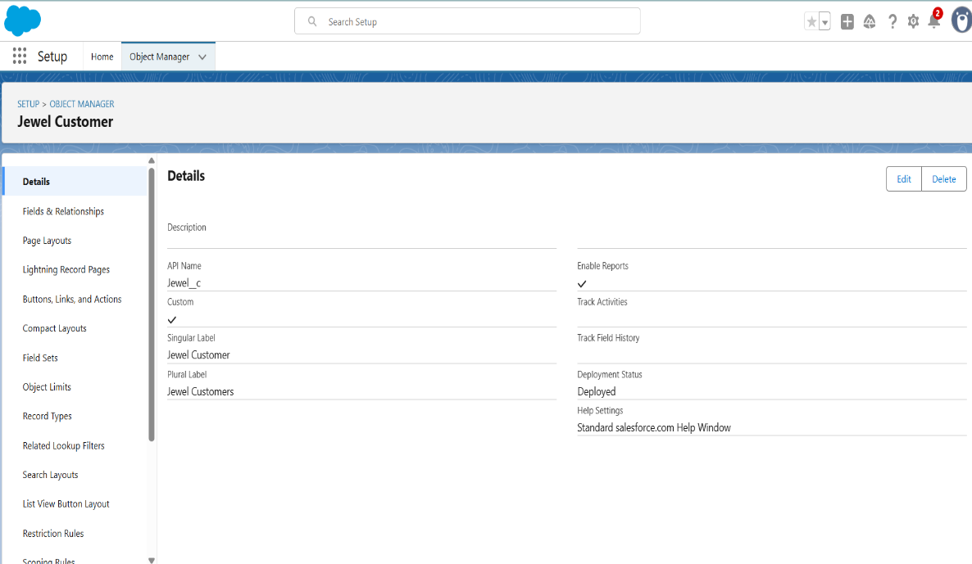

**Create Item Object:**

The purpose of creating an Item object is to manage the inventory of gold and silver items.

To create an object:

1. From the setup page   >> Click on Object Manager >> Click on Create >> Click on Custom Object.
2. Enter the label name >> Item
3. Plural label name >> Items
4. Enter Record Name Label and Format

* Record Name >> Item Id
* Data Type >> Auto Number
* Display Format >> Item- {00}
* Starting Number >> 1

1. Click on Allow reports.
2. Allow search >> Save.

**Note: Create 3 more objects with label names as Customer Order, Price, Billing**

**(**Use “Auto Number” as a data type for Customer Order, Price, Billing).

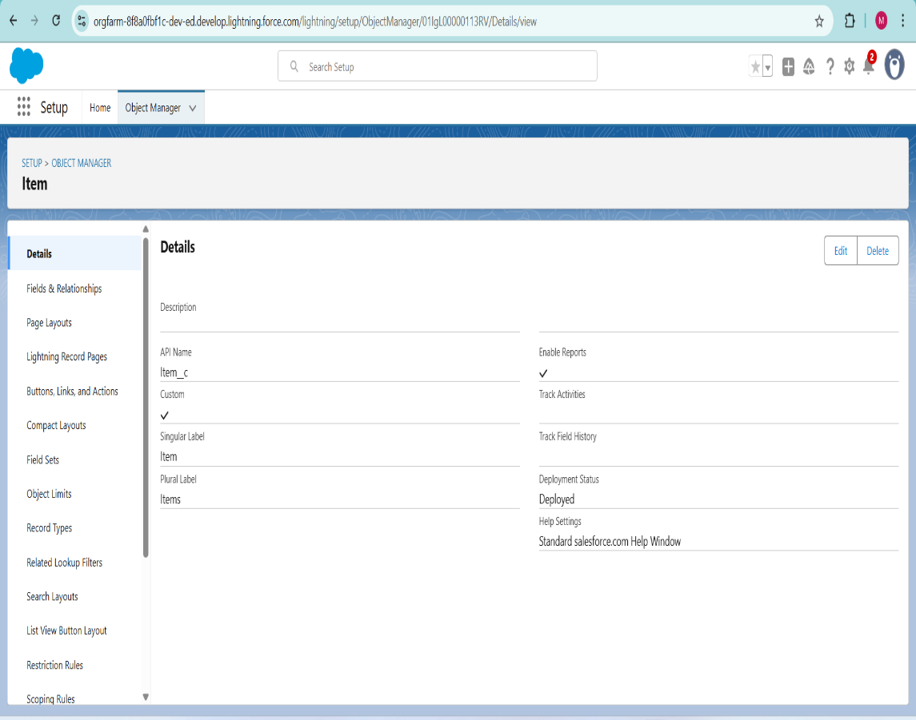

**Tabs:**

**What is Tab:**A tab is like a user interface that is used to build records for objects and to view the records in the objects.

**Types of Tabs:**

1. Custom Tabs

Custom object tabs are the user interface for custom applications that you build in salesforce.com. They look and behave like standard salesforce.com tabs such as accounts, contacts, and opportunities.

1. Web Tabs

Web Tabs are custom tabs that display web content or applications embedded in the salesforce.com window. Web tabs make it easier for your users to quickly access content and applications they frequently use without leaving the salesforce.com application.

1. Visualforce Tabs

Visualforce Tabs are custom tabs that display a Visualforce page. Visualforce tabs look and behave like standard salesforce.com tabs such as accounts, contacts, and opportunities.

1. Lightning Component Tabs

Lightning Component tabs allow you to add Lightning components to the navigation menu in Lightning Experience and the mobile app.

1. Lightning Page Tabs

Lightning Page Tabs let you add Lightning Pages to the mobile app navigation menu.

Lightning Page tabs don't work like other custom tabs. Once created, they don't show up on the All-Tabs page when you click the Plus icon that appears to the right of your current tabs. Lightning Page tabs also don't show up in the Available Tabs list when you customize the tabs for your apps.

Use Case:

Creating Objects and storing Jewels data is the very first step in the requirements they want. Now to access the stored data by an Owner (Gold Smith) in the organisation Admin needs to create Tabs. By designing a dedicated Tab, businesses can improve user experience, simplify navigation, and provide quick access to critical information, enhancing productivity and ensuring efficient utilisation of Salesforce's capabilities.

**Creating a Custom Tab**

To create a Tab:(Customer)

1. Go to setup page >> type Tabs in Quick Find bar >> click on tabs >> New (under custom object tab)
2. Select Object (Jewel Customer) >> Select any tab style >> Next (Add to profiles page) keep it as default >> Next (Add to Custom App) keep it as default >> Save.

**To create a Tab:(Item)**

1. Go to setup page >> type Tabs in Quick Find bar >> click on tabs >> New (under custom object tab)
2. Select Object (Item) >> Select the tab style >> Next (Add to profiles page) keep it as default >> Next (Add to Custom App) keep it as default >> Save.

Note: Now create tabs for Customer Order, Price, Billing objects.

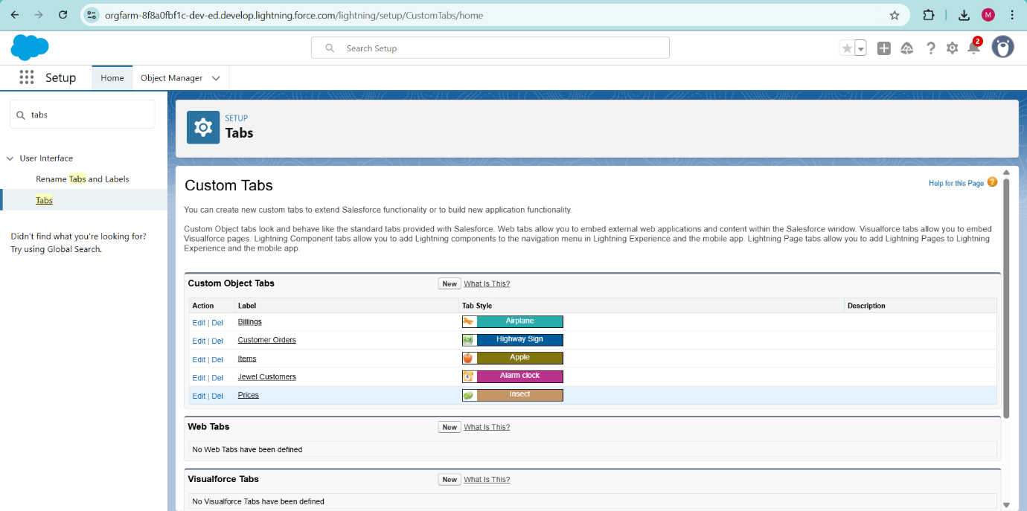

**The Lightning App**

An app is a collection of items that work together to serve a particular function. In Lightning Experience, Lightning apps gives users access to sets of objects, tabs, and other items all in one convenient bundle in the navigation bar.

Lightning apps let you brand your apps with a custom color and logo. You can even include a utility bar and Lightning page tabs in your Lightning app. Members of your org can work more efficiently by easily switching between apps.

**Use Case:**

Well done you have reached close to your requirement by creating the objects to store the organization’s data. Making a database for an organization is just not enough to reach out the requirements, the task is how the users at the organization can access the objects you have created for them. As an Admin for the organization, it's your duty to make sure every user of the organization is able to access the data modelling structure.

**Create a Lightning App**

To create a lightning app page:

1. Go to setup page >> search “app manager” in quick find >> select “app manage Then click Next >> (App option page) Set Navigation Style as Console Navigation >> Next.
2. Fill the app name in app details and branding as follow  
   App Name: Jewellery Inventory System.  
   Developer Name: This will auto populated  
   Description: Elevate your look with elegance  
   Image: optional (if you want to give any image you can otherwise not mandatory)  
   Primary colour hex value: keep this default.
3. Then click Next >> (App option page) Set Navigation Style as Console Navigation >> Next.
4. (Utility Items) keep it as default >> Next.
5. To Add Navigation Items:

Search for the item in the

(Jewel Customer, Item, Customer Order, Price, Billing, Reports, Dashboard) from the search bar and move it using the arrow button >> Next >> Next.

1. To Add User Profiles:
2. Search profiles (System administrator) in the search bar >> click on the arrow button >> save & finish.

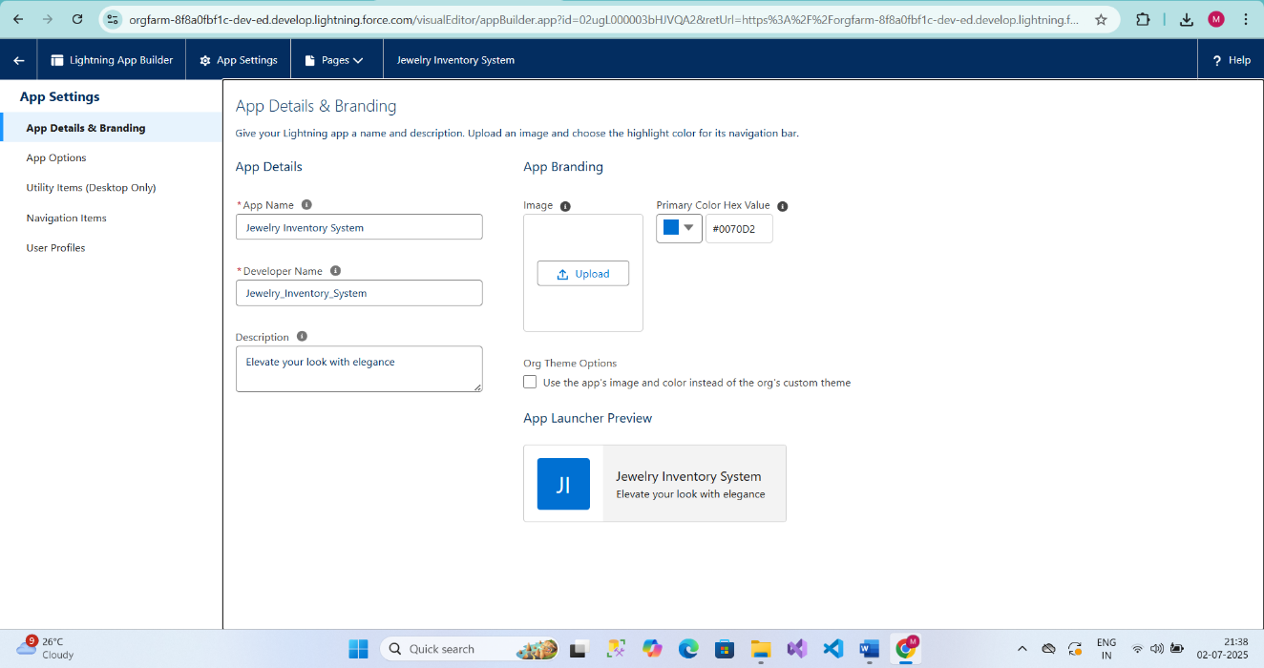

**Fields**

When we talk about Salesforce, Fields represent the data stored in the columns of a relational database. It can hold any valuable information that you require for a specific object. Hence, the overall searching, deletion, and editing of the records become simpler and quicker.

Types of Fields:

1. Standard Fields
2. Custom Fields

Standard Fields:

As the name suggests, the Standard Fields are the predefined fields in Salesforce that perform a standard task. The main point is that you can’t simply delete a Standard Field until it is a non-required standard field. Otherwise, users have the option to delete them at any point from the application freely. Moreover, we have some fields that you will find common in every Salesforce application. They are,

>> Created By

>> Owner

>> Last Modified

>> Field Made During Object Creation

Custom Fields:

On the other side of the coin, Custom Fields are highly flexible, and users can change them according to requirements. Moreover, each organiser or company can use them if necessary. It means you need not always include them in the records, unlike Standard fields. Hence, the final decision depends on the user, and he can add/remove Custom Fields of any given form.

**Use Case:**

Now it’s time for you to think out of the box for your organisation. You have successfully created the database objects for the organisation but now all eyes turn on you as you have to define what sort of information the objects store which you have created. As a life saver of your organisation, you come up with the idea of creating fields to store different types of data.

**Creating Lookup Relationship**

A Lookup relationship is a type of relationship in Salesforce that connects two objects together based on a field known as the Lookup field. It establishes a relationship between a child object and a parent object, allowing the child object to reference the parent object.

To Create a relationship between Jewel Customer & Customer Order Objects.

1. Go to the setup page >> click on object manager >> type object name(Customer Order) in the quick find bar >> click on the object.
2. Click on fields & relationship >> click on New.
3. Select “Lookup relationship” as data type and click Next.
4. Select the related object “Jewel Customer”.
5. Give Field Label as “Customer” and click Next.
6. Next >> Next >> Save.

### **Creating a Master-Detail Relationship**

Master-detail relationship is a type of relationship between two objects where the master object controls certain behaviours and settings of the detail object. Here are a few use cases that demonstrate the use of master-detail relationships

Creating Master-Detail Relationship between Item & Customer Order Object.

To Create a Master-Detail relationship:

1. Go to the setup page >> click on object manager >> type object name (Customer Order) in the quick find bar >> click on the object.

2.Click on fields & relationships >> click on New.

3.Select “Master-Detail relationship” as data type and click Next.

4.Select the related object “Item”.

5.Give Field Label as “Item” and click Next.

6.Next >> Next >> Save.

**Creating Text Field in Jewel Customer Object**

To create fields in an object:

1. Go to setup >> click on Object Manager >> type object name (Jewel Customer) in quick find bar >> click on the object.
2. Now click on “Fields & Relationships” >> New
3. Select Data type as “Text”.
4. Click on Next
5. Fill the above as following:

* Field Label: City
* Length: 20
* Field Name: gets auto generated
* Click on Next >> Next >> Save and new.

### **Creating the Phone field in object Jewel Customer**

To create fields in an object:

click on the object Go to setup >> click on Object Manager >> type object name (Jewel Customer) in quick find bar >>.

1. Now click on “Fields & Relationships” >> New
2. Select Data type as “Phone” and click Next.
3. Given the Field Label as “Phone”.

Field Name will be auto populated, and click on Next? Next >> Save & new.

**Creating the Email field in object Jewel Customer**

To create fields in an object:

1. Go to setup >> click on Object Manager >> type object name (Jewel Customer) in quick find bar >> click on the object.
2. Now click on “Fields & Relationships” >> New
3. Select Data type as “Email” and click Next.
4. Given the Field Label as “Email”.
5. Field Name will be auto populated, and click on Next >> Next >> Save.

**Creating the number field in Item object**

To create fields in an object:

1. Go to setup >> click on Object Manager >> type object name (Item) in quick find bar >> click on the object.
2. Now click on “Fields & Relationships” >> New
3. Select Data type as “Number” and click Next.
4. Given the Field Label as “Purity” and length as “2”.
5. Field Name will be auto populated, and click on Next >> Next >> Save.

**Creating Picklist Field in Item Object**

To create fields in an object:

1. Go to setup >> click on Object Manager >>type object name (Item) in quick find bar >> click on the object.
2. Now click on “Fields & Relationships”? New.
3. Select Data type as “Picklist” and click Next.
4. Enter Field Label as “Item Type”.
5. In values select “Enter values (Gold, Silver), with each value separated by a new line"
6. Click Next >> Next >> Next >> Save.

**Creating Currency Field in Price Object**

To create fields in an object:

1. Go to setup >> click on Object Manager >> type object name (Price) in quick find bar >> click on the object.
2. Now click on “Fields & Relationships” >> New.
3. Select Data type as “Currency” and click Next.
4. Enter Field Label as “Gold Price” and length as “8”and decimal 5. Field name will be auto generated.
5. Click Next >> Next >> Next >> Save

**Creating Formula Field (Cross Object) in Item Object**

To create fields in an object:

(Note: Create a Lookup Relationship in Item Object to Price Object with Field Name: Prices)

1. Go to setup >> click on Object Manager >> type object name (Item) in quick find bar >> click on the object.

1. Now click on “Fields & Relationships” >> New.
2. Select Data type as “Formula” and click Next.
3. Give Field Label and Field Name as “Gold Price” and select formula return type as “Currency” and click next.
4. Under Advanced Formula write down the formula: Prices__r. Gold_price__c / 10.
5. click “Check Syntax” and Next >> Next >> Save & New.

### Creating Remaining Fields in Objects

Now create the remaining fields using the data types mentioned.

|  |  |  |
| --- | --- | --- |
| s.no | Object name | Fields |
| 1 | Jewel Customer | |  |  | | --- | --- | | Field Name | Data type | | State | Text (20) | | Street | Text (20) | | Country | Text (18) | | Zip/Postal code | Text (6) | |

|  |  |  |  |  |
| --- | --- | --- | --- | --- |
| 2 | Price | |  |  | | --- | --- | | Silver Price | Currency  (Length=8, Decimal=5) | |

|  |  |  |  |  |  |  |  |  |  |  |  |  |  |  |  |  |  |  |  |  |  |  |  |  |  |  |  |  |  |  |  |  |  |  |  |  |  |  |
| --- | --- | --- | --- | --- | --- | --- | --- | --- | --- | --- | --- | --- | --- | --- | --- | --- | --- | --- | --- | --- | --- | --- | --- | --- | --- | --- | --- | --- | --- | --- | --- | --- | --- | --- | --- | --- | --- | --- |
| 3 | Item | |  |  | | --- | --- | | Field Label: Customer Name | Lookup Relationship with Jewel Customer Object | | Ornament | Text (20) | | Weight | Number  (Length=8, Decimal=5) | | Stone Weight | Number  (Length=5, Decimal=5) | | Percentage | Number  (Length=2, Decimal=0) | | Stone/Other Price | Currency  (Length=8, Decimal=2) | | Expected Days of Return | Picklist   |  | | --- | | 1-3 Days  4-5 Days  6-7 Days  8-10 Days | | | Priority | Picklist   |  | | --- | | Low  Medium  High  Critical | | | Silver Price | Formula     (Return Type: Number)  (Decimal=3)   |  | | --- | | (Prices__r. Silver_price__c / 1000) | | | Purity Gold Price | Formula     (Return Type: Currency)            (Decimal=2)   |  | | --- | | ((Prices__r. Gold_price__c * Purity) / 24) / 10 | | | Total Weight | Formula      (Return Type: Number)  (Decimal=3)   |  | | --- | | (Weight - Stone_weight__c) | | | Amount | Formula  (Return Type: Currency)  (Decimal=3)   |  | | --- | | IF (ISPICKVAL (Item_Type__c, “Gold"), Total_weight__c *   Purity_Gold_price__c, Total_weight__c * Silver_price__c) | | | KDM | Formula  (Return Type: Currency)  (Decimal=0)   |  | | --- | | (Amount    * Percentage) / 100 | | | Making Charges | Formula  (Return Type: Currency)  (Decimal=0)   |  | | --- | | IF (ISPICKVAL (Item_Type__c, “Gold"), Weight   * 300, Weight * 10) | | |

|  |  |  |  |  |  |
| --- | --- | --- | --- | --- | --- |
| 4 | Customer Order | |  |  |  | | --- | --- | --- | | Order Status | Picklist   |  | | --- | | Started  Not Started  On Hold  Completed  Not Completed | | |

|  |  |  |  |  |  |  |  |  |  |  |  |  |  |  |  |  |  |  |  |  |  |  |  |  |  |  |  |  |  |  |  |
| --- | --- | --- | --- | --- | --- | --- | --- | --- | --- | --- | --- | --- | --- | --- | --- | --- | --- | --- | --- | --- | --- | --- | --- | --- | --- | --- | --- | --- | --- | --- | --- |
| 5 | Billing | |  |  | | --- | --- | | Field Label: Item | Lookup Relationship                with Item Object | | Ornament | Formula      (Return Type: Text)     |  | | --- | | Item__r. Ornament | | | Stone weight | Formula      (Return Type: Number)              (Decimal=2)     |  | | --- | | Item__r. Stone_weight__c | | | Weight | Formula         Return Type: Number              (Decimal=2)   |  | | --- | | Item__r. Total_weight__c | | | Amount | Formula      (Return Type: Currency)  (Decimal=2)   |  | | --- | | Item__r. Amount | | | Gold/Silver Price | Formula      (Return Type: Currency)  (Decimal=2)   |  | | --- | | IF (ISPICKVAL (Item__r. Item_Type__c, “Gold"), Item__r. Gold_price__c, Item__r. Silver_price__c) | | | KDM Charge | Formula      (Return Type: Currency)  (Decimal=0)   |  | | --- | | Item__r.KDM__c | | | Making Charges | Formula      (Return Type: Currency)  (Decimal=2)   |  | | --- | | Item__r. Making_Charges__c | | | Stones/Stones/another price | Formula      (Return Type: Currency)  (Decimal=2)   |  | | --- | | Item__r. Stone_other_price__c | | | Total Amount | Formula      (Return Type: Currency)  (Decimal=0)   |  | | --- | | Amount   + KDM_Charge__c + Stone_other_price__c + Making_Charges__c | | |

**Schema Builder**

Schema Builder is a powerful tool within Salesforce that allows you to visualise, explore, and design the relationships between objects in your Salesforce organisation. It provides a graphical representation of the data model, making it easier to understand the structure and connections between different objects.

Creating Schema Builder

1.Go to setup >> click on Object Manager >> Schema Builder.

2.Select objects >> Enter Objects as “Jewel Customer, Item, Customer Order, Price, Billing objects” in quick box and select them.

**Creating the Field Dependencies**

Use case:

Field Dependencies are used to create relationships between fields within an object. They allow you to control the visibility and availability of fields based on the values selected in other fields.

1. Go to setup >> click on Object Manager >> type object name (Item) in quick find bar >>click on the object.
2. Click on Fields & Relationships and click on the Priority field.
3. Search for Field Dependencies and click on New.
4. Select Controlling Field as “Priority” and Depending field as “Expected Days of Return”? Continue.
5. Select the “Expected Days of Return” values of related Priority values and Click on Include Values >> Save.

**Creating the validation rule**

Creating the validation rule for Postal Code field in Jewel Customer object

Note: check whether the fields mentioned in the formula field are created or not, if not go to activity 10 and create those fields mentioned in Jewel Customer object.

Go to setup >> click on Object Manager >> type object name (Jewel Customer) in quick find bar >> click on the object.

Enter the Rule name as “Postal Code “.

Insert the Error Condition Formula as : -

AND (

 OR (

 LEN (Zip_Postal_code__c) <> 6,

NOT (REGEX (Zip_Postal_code__c, "^ [0-9]{6} $"))), NOT(ISBLANK(Zip_Postal_code__c)))

1. Enter the Error Message as “Must contain 6 digits”, select the Error location as Field and select the field as “Zip/Postal code”, and click Save.

NOTE: Create One more Validation rule for Jewel Customer object.

1. Enter Rule name as “Validation Rule for JewelCustomerObject “.
2. Insert the Error Condition Formula as: -

    OR (ISBLANK (City__c), ISBLANK (Country), ISBLANK(Phone__c), ISBLANK (State__c), ISBLANK (Street))

Enter the Error Message as “Please fill Required fields”, select the Error location as Top of Page and click Save.

Create Validation rule for Item object.

1. Enter Rule name as “Validation Rule for Item “.
2. Insert the Error Condition Formula as : - OR( ISBLANK(  Amount  ) , ISBLANK(  Customer_Name__c  ) ,ISBLANK( Gold_price__c ),ISBLANK( KDM__c ),ISBLANK( Ornament ),ISBLANK( percentage ),ISBLANK( Making_Charges__c ),ISBLANK( Prices ),ISBLANK( Stone_weight__c ),ISBLANK( Silver_price__c ),ISBLANK( Stone_other_price__c ),ISBLANK( Stone_weight__c ),ISBLANK( Weight ))
3. Enter the Error Message as “Please fill Required fields”, select the Error location as Top of Page and click Save.

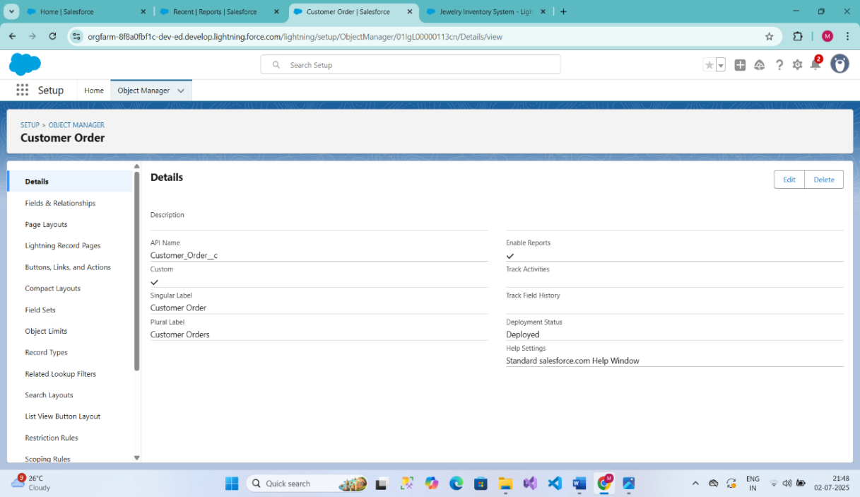

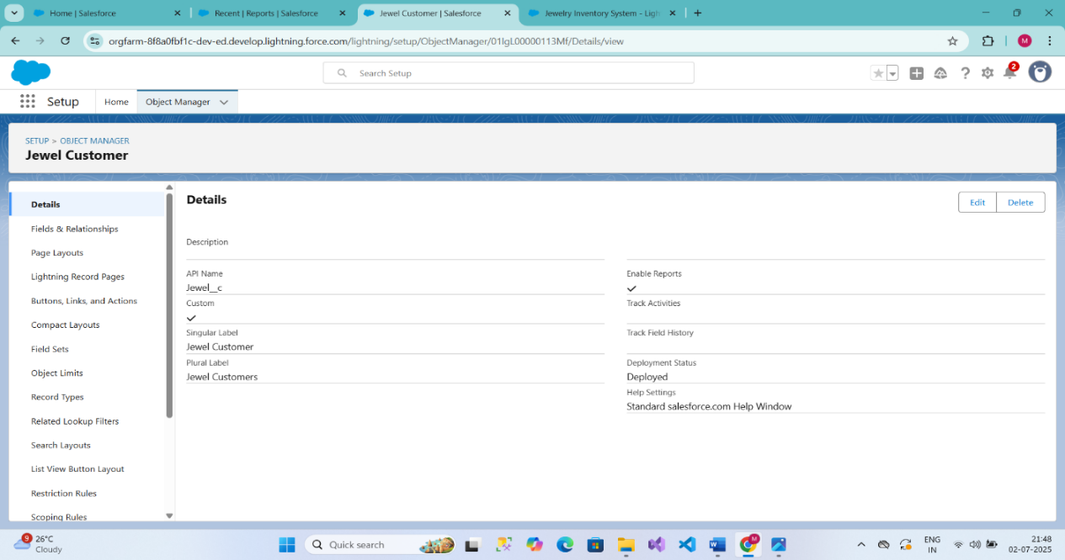

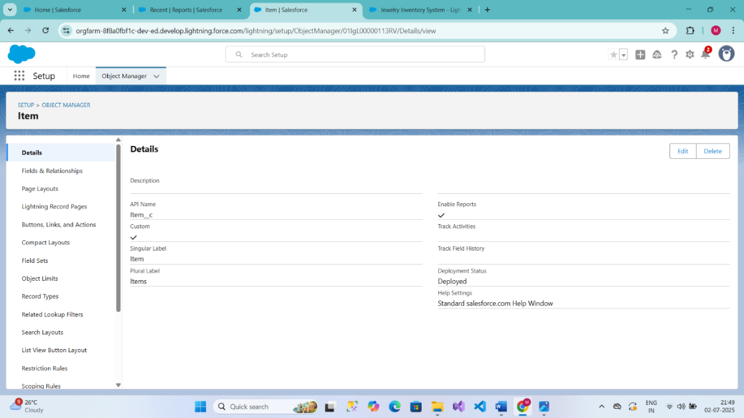

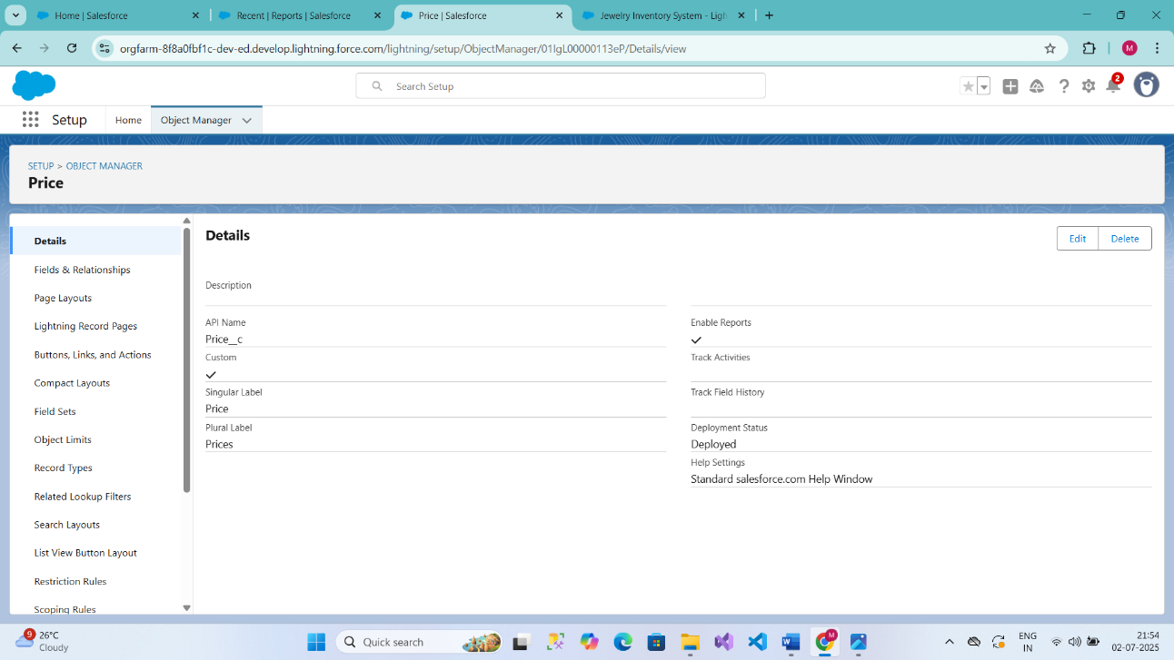

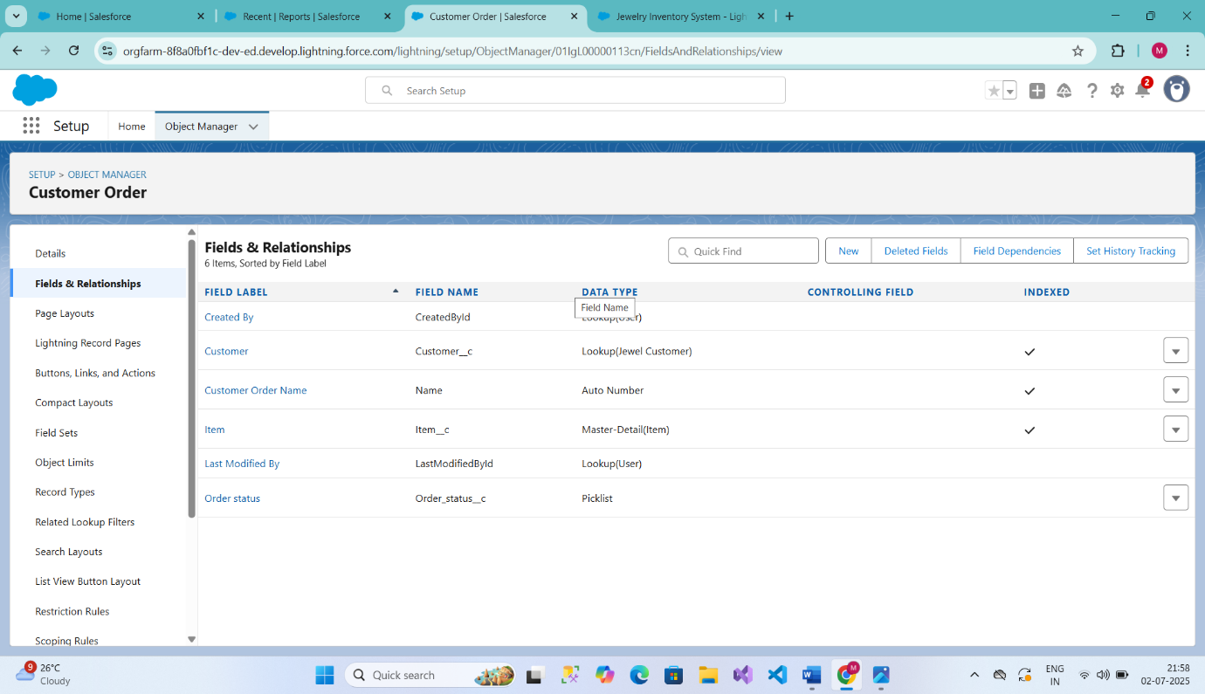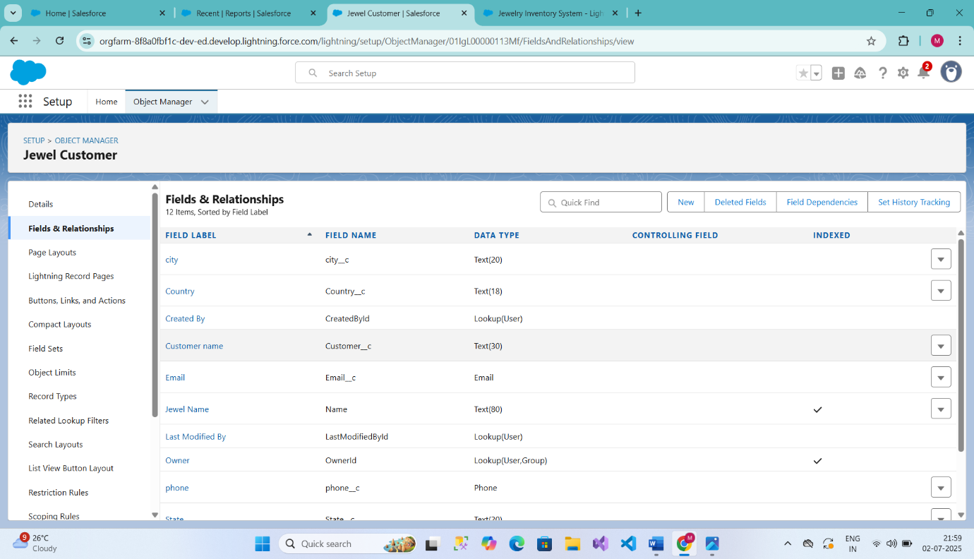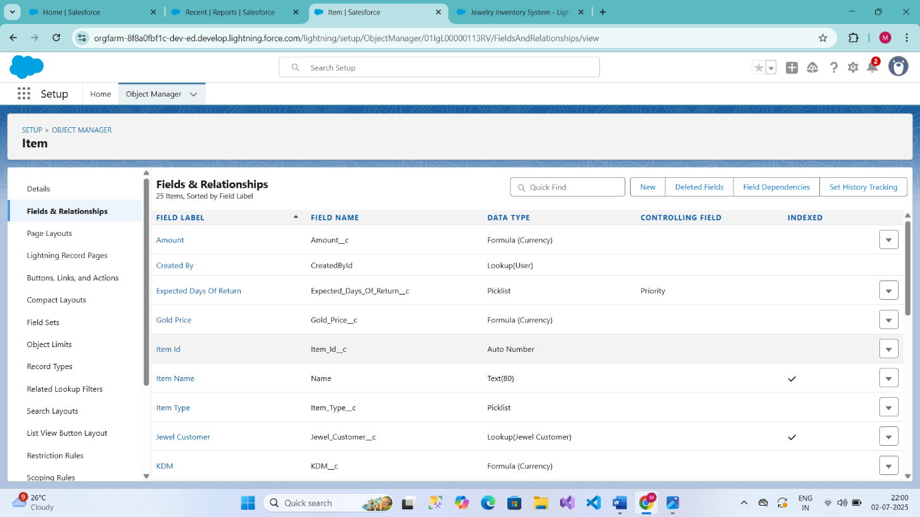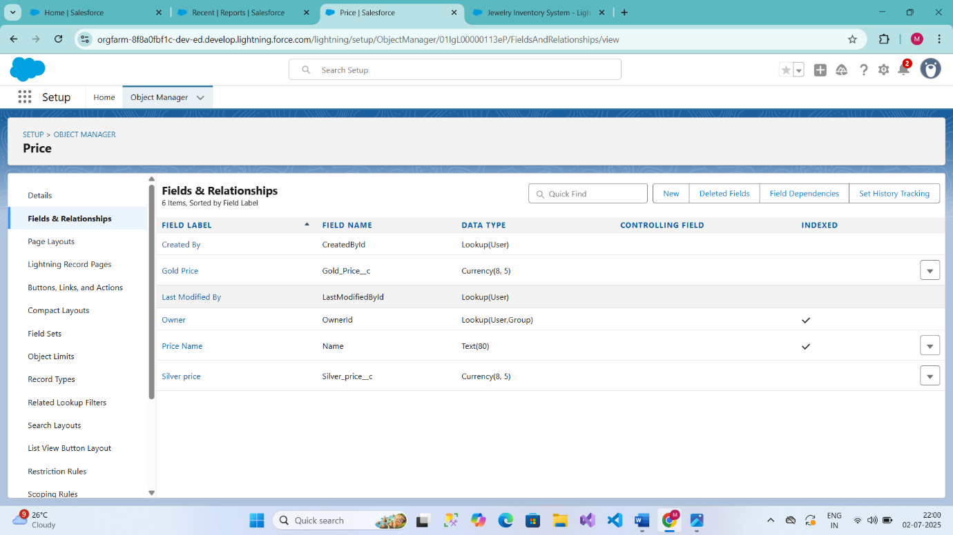

**Profiles:**

A profile is a group/collection of settings and permissions that define what a user can do in salesforce. Profile controls “Object permissions, Field permissions, User permissions, Tab settings, App settings, Apex class access, Visualforce page access, Page layouts, Record Types, Login hours & Login IP ranges. You can define profiles by the user's job function. For example, System Administrator, Developer, Sales Representative.

Types of profiles in salesforce

1. Standard profiles:

By default, salesforce provides below standard profiles.

* Contract Manager
* Read Only
* Marketing User
* Solutions Manager
* Standard User
* System Administrator.

We cannot deleted standard ones

Each of these standard ones includes a default set of permissions for all of the standard objects available on the platform.

1. Custom Profiles:

Custom ones defined by us.

They can be deleted if there are no users assigned with that particular one.

**Use Case:**

Great work Admin, you have done so good till now. The Goldsmith wants to differentiate the users based on their functionalities, position and based on this those users need to have the minimum access to the database object in the organisation. Now it's time to use your Admin skills to focus on the users, their functionality and position in the organisation in order to achieve the Goldsmith Smith requirements.

**Gold Smith Profile**

To create a new profile:

1. Go to setup >> type profiles in quick find box >> click on profiles >> clone the desired profile (System Administrator) >> enter profile name (Gold Smith) >> Save.
2. While still on the profile page, then click Edit.
3. Scroll down to Custom Object Permissions and Give access permissions for Jewel Customer, Item, Customer Order, Prices, Billings
4. Scroll down and Click on Save.

**Worker Profile**

1. Go to setup >> type profiles in quick find box >> click on profiles >> clone the desired profile (Salesforce Platform User) >> enter profile name () >> Save.
2. While still on the profile page, then click Edit.
3. Scroll down to Custom Object Permissions and Give access permissions for Items, Price and Customer Order objects.
4. Scroll down and Click on Save

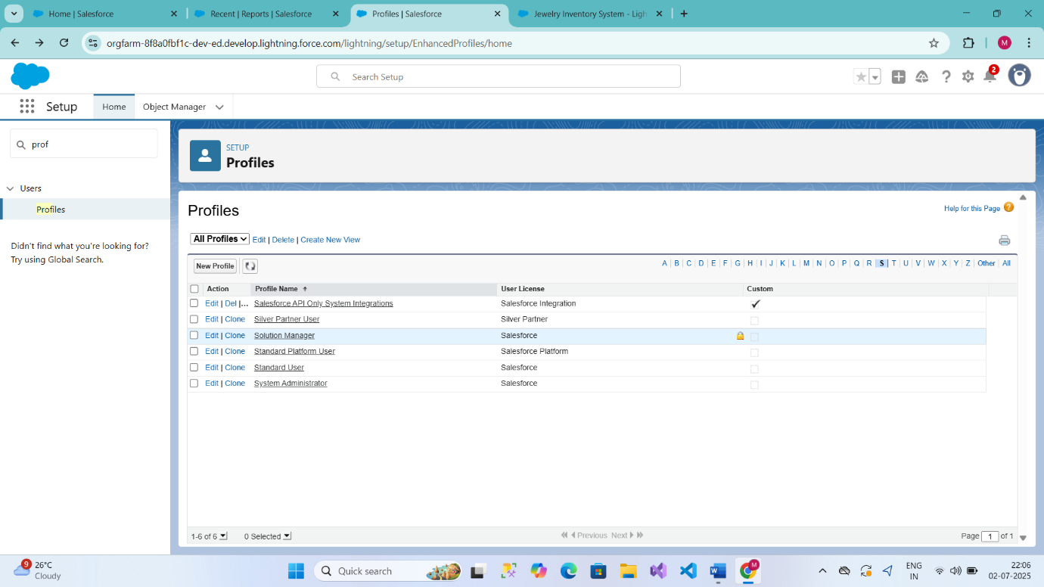

**Roles:**

A role in Salesforce defines a user's visibility access at the record level. Roles may be used to specify the types of access that people in your Salesforce organisation can have to data. Simply put, it describes what a user could see within the Salesforce organisation.

**Use Case:**

You have successfully fulfilled the 1st requirement i.e., differentiating the users based on the functionality. Now comes the 2nd task of differentiating the users based on their position, using your excellent admin skills and expanding the custom roles for the organisation and assigning it to the users.

**Creating Gold Smith Role**

From setup >> Go to quick find >> Search for Roles >> click on set up roles.

Click on Expand All and click on add role under whom this role works.

Give Label as “Gold Smith” and Role name gets auto populated. Check to whom this role (Gold Smith) reports. Then click on Save.

Note:

Create one more role as Worker which reports to Gold Smith.

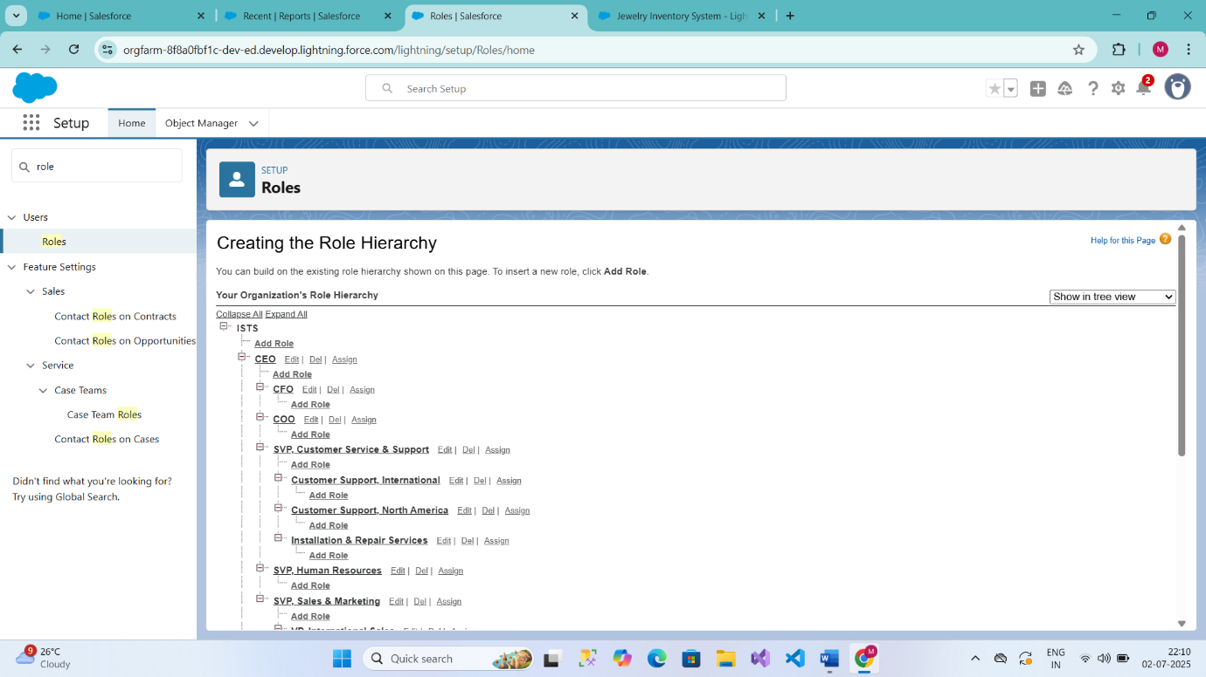

**Users:**

A user is anyone who logs in to Salesforce. Users are employees at your company, such as sales reps, managers, and IT specialists, who need access to the company's records. Every user in Salesforce has a user account. The user account identifies the user, and the user account settings determine what features and records the user can access.  
  
Every user in Salesforce has a user account. The user account identifies the user, and the user account settings determine what features and records the user can access. Each user account contains at least the following:

* Username
* Email Address
* User's First Name (optional)
* User's Last Name
* Alias
* Nickname
* Licence
* Profile
* Role (optional)

**Create User**

1. Go to setup >> type users in quick find box >> select users >> click New user.
2. Fill in the fields
3. First Name: Niklaus
4. Last Name: Mikaelson
5. Alias: Give a Alias Name
6. Email id: Give your Personal Email id
7. Username: Username should be in this form: text@text.text
8. Nick Name: Give a Nickname
9. Role: Gold Smith
10. User licence: Salesforce
11. Profiles: Gold Smith

**Create User**

1. Go to setup >> type users in quick find box >> select users >> click new user.
2. Fill in the fields

* First Name: Kol
* Last Name: Mikaelson
* Alias: Give a Alias Name
* Email id: Give your Personal Email id
* Username: Username should be in this form: text@text.text
* Nick Name: Give a Nickname
* Role: Worker
* User licence: Salesforce Platform
* Profiles: Worker

1. Save.

Note:

Create two more users as mentioned in activity 2 using the same profile.

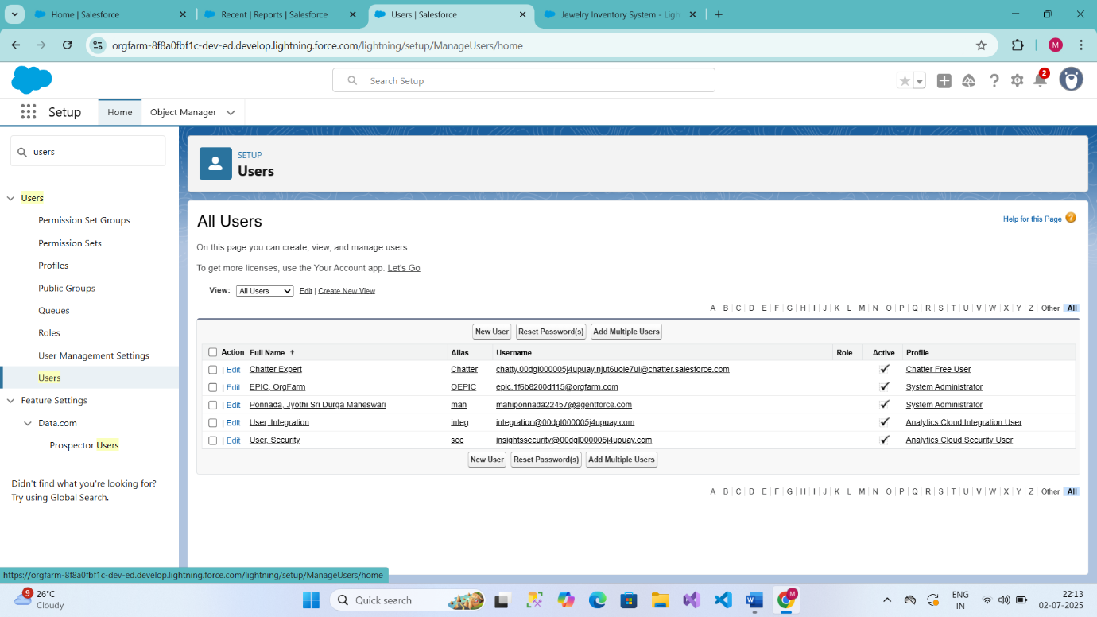

**Page layouts:**

Page Layout in Salesforce allows us to customise the design and organise detail and edit pages of records in Salesforce. Page layouts can be used to control the appearance of fields, related lists, and custom links on standard and custom objects' detail and edit pages.

**Use Case:**

Hurray!! you have completed the data model structure for your organisation but while looking at the detailed and edit pages it seems to be so clumsy, so decide to organise the page in a pleasant way for the sake of good and pleasant appearance and assemble all different kinds of information in different sections in order.

**To Create a Gold Page layout**

1. Go to Setup >> Click on Object Manager >> Search for the object (Item) >> From drop down click on Edit.

Click on Page layout >> Click on New.

Give Page layout Name as “Page Layout for Gold” and click on Save.

Arrange the field as shown in the Information Section, remove fields which are related to Silver and click Ok.

Click Save.

Make sure your page layout looks like the picture above

**To Create a Silver Page layout**

1. Go to Setup >> Click on Object Manager >> Search for the object (Item) >> From drop down click on Edit.
2. Click on Page layout >> Click on New.
3. Give Page layout Name as “Page Layout for Silver” and click on Save.
4. Arrange the field as shown in the Information Section, remove fields which are related to Gold and click Ok.

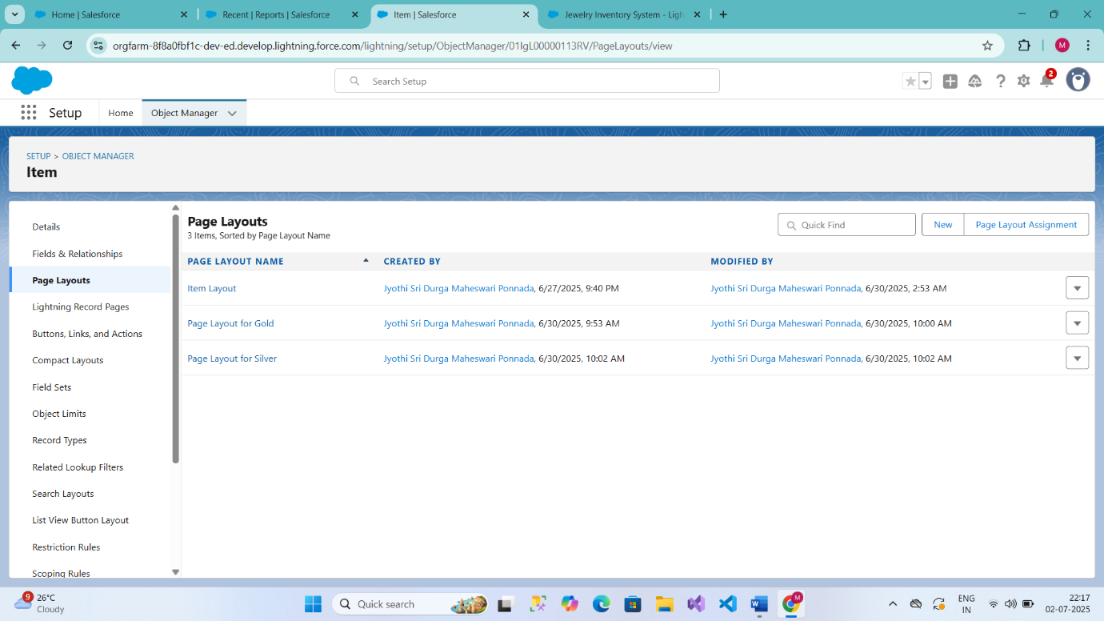

**Record Types:**

Record Types are a way of grouping many records of one type for that object. These can be applied to any standard or custom object, and allow you to have a different page layout, fields, required fields, and picklist values. Record types allow administrators to create a different page layout with custom picklist fields and values for the same business process and various business processes**.**

**Use Case:**

All things done for the organisation. But some of the organisations feel it difficult to fill up all the details while creating a record, so Goldsmith assigned you a task to create different forms for gold and silver records based on their mode of work. As an Admin, you know how to achieve this.

**To create a Record Type**

1. Go to setup >> click on Object Manager >> type object name (Item) in quick find bar >> click on the object.
2. Click on the Record Types >> click New.
3. Select Existing Record as “Master”, Record type Label as “Gold”, Description as “Gold items information”.
4. Uncheck for “Make Available”.
5. Scroll down and check for the Gold Smith, Worker & System Administrator profile and click on Next.
6. Select “Apply a different layout for each profile”, and change page layout to “Page Layout for Gold “for Gold Smith, Worker and System Administrator >> save & new.
7. Note: Create another Record Type with name “Silver” following the steps from Activity1(Use page layout for Silver).

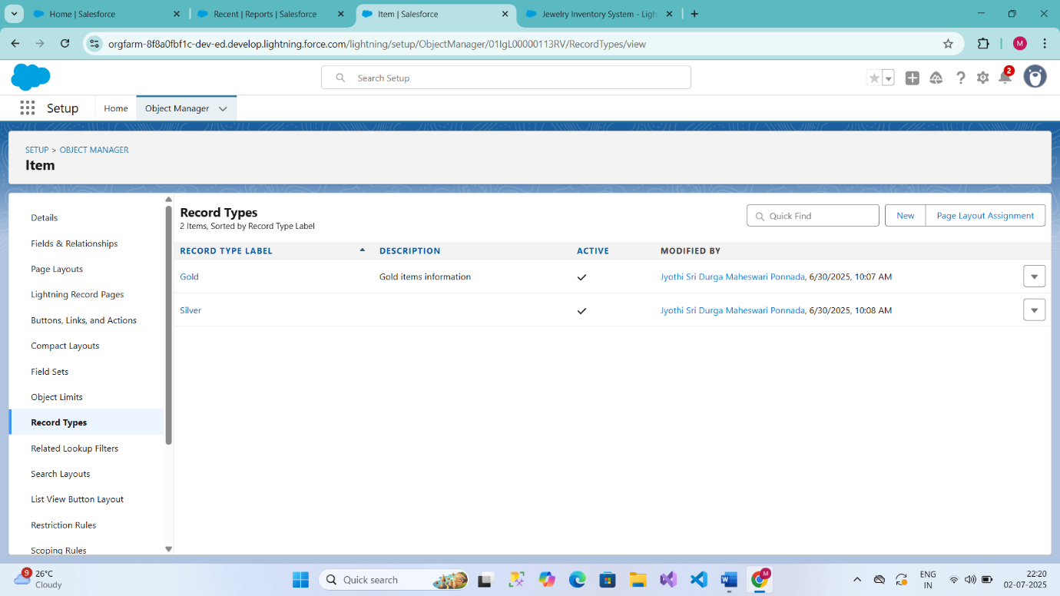

**Permission sets:**

A standard permission set consists of a group of common permissions for a particular feature associated with a permission set licence. Using a standard permission set saves you time and facilitates administration because you don't need to create the custom permission set.

**Creating permission set**

A permission set is a collection of settings and permissions that give users access to various tools and functions. Permission sets extend users' functional access without changing their profiles. Users can have only one profile but, depending on the Salesforce edition, they can have multiple permission sets.

1. Go to setup >> type “permission sets” in quick search >> select permission sets >>
2. Enter the label name as “Per to Worker”, API will be auto populated >> save.
3. Under Apps Select object settings.
4. Click on Items object >> click on Edit >> under Item: Record Type Assignments, enable Gold, Silver >> Object permission check for read, edit and create.
5. Click on Save.
6. After saving the permission click on the Manage assignment
7. Now click on the Add Assignment.
8. Now select the users which you have created in user milestone, using Worker profile and click on Next >> Assign >> Done.

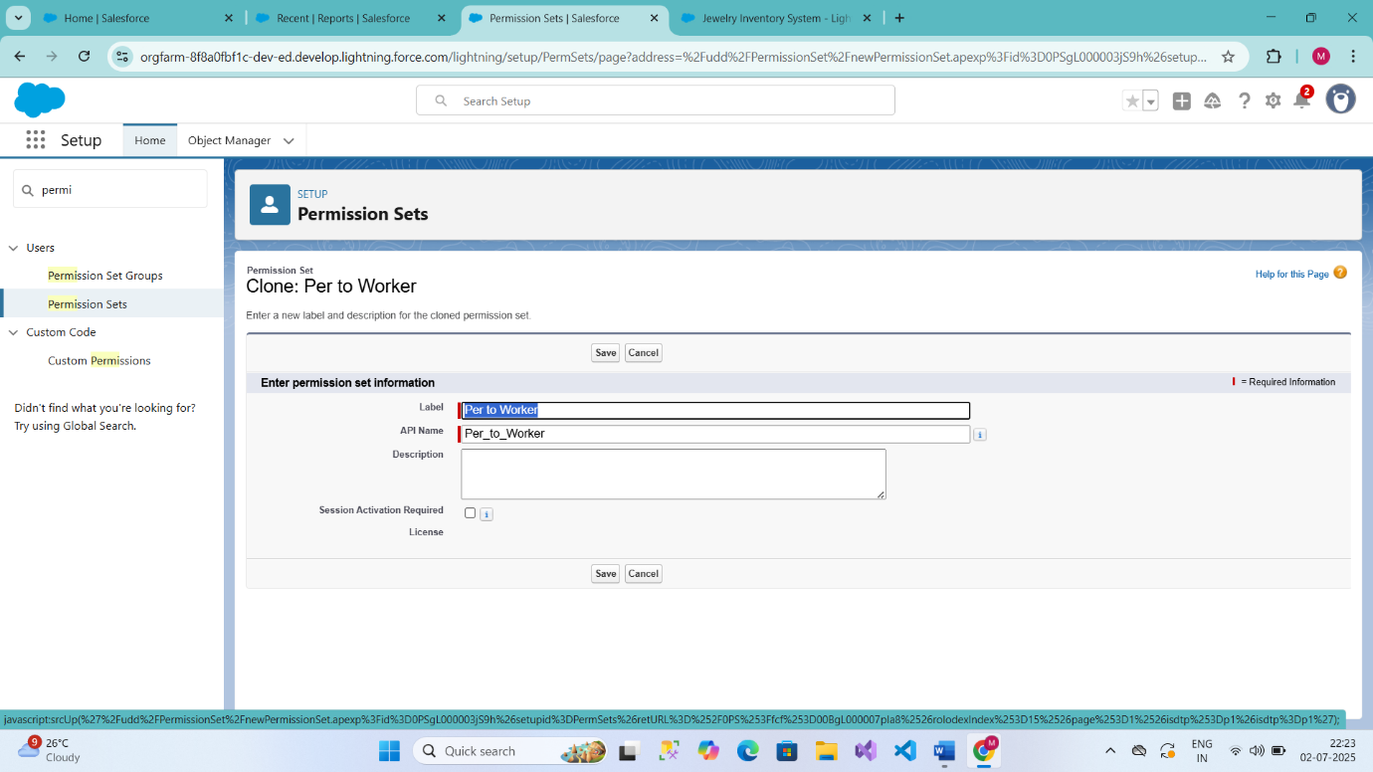

**Trigger:**

**Use Case:** Trigger and Trigger handler is designed to handle scenarios where we used to update the "Paid Amount" field on a custom object called "Billing" based on the value in a field named "Paying Amount" during both record insertion and update operations. It Calculates and updates the "Paid Amount" field based on the existing "Paid Amount" and the new "Paying Amount" during record updates. This approach ensures that the "Paid Amount" accurately reflects the payments made by customers and provides a history of changes to the "Paid Amount" over time. **Trigger:**A trigger is a piece of Apex code that automatically runs before or after specific events, like record insertion, update, or deletion. Triggers are used to customise and automate actions in response to these events.

**Create a Trigger Handler class**

**Trigger handler:**

A trigger handler is a design pattern that organises trigger logic into separate classes. This helps in keeping code organised, reusable, and easier to maintain. The trigger handler class contains methods that handle the specific logic for different trigger events, improving code structure and readability. This approach is particularly useful for complex triggers or projects with multiple triggers, as it promotes modular coding practices and reduces the chances of code duplication.

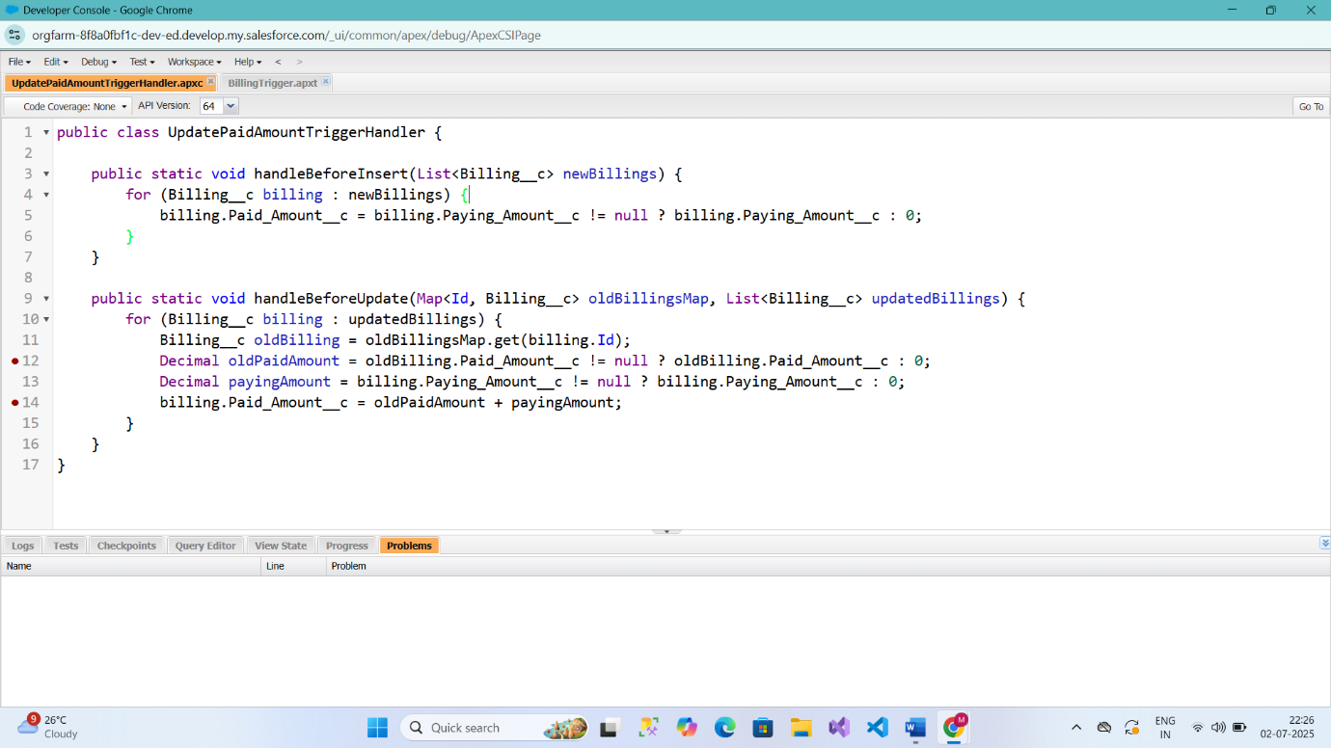

**Create The Trigger:**

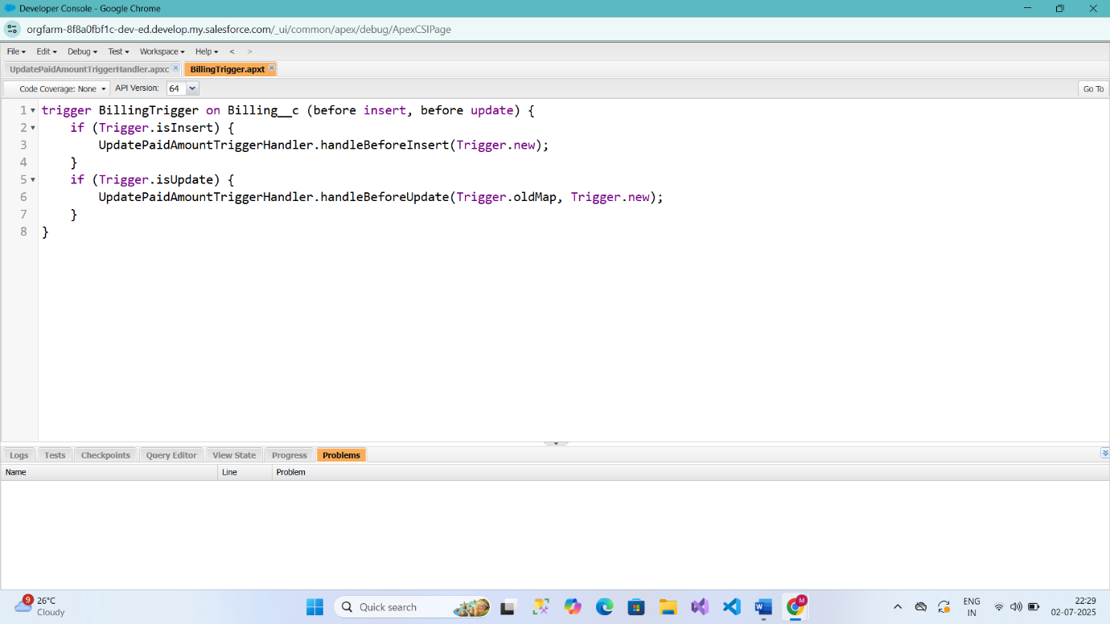

**User Adoption:**

**Use Case:**

As a new Administrator, you perform user management tasks like creating and editing users, resetting passwords, granting permissions, configuring data access, and much more. In this unit, you will learn about users and how you add users to your Salesforce org.

**Create a Record (Jewel Customer)**

Click on App Launcher on the left side of the screen.

Search Jewellery Inventory System & click on it.

1. Click on Drop Down and Click on the Jewel Customer tab
2. Click New.
3. Fill the Details and click on Save.

**View a Record (Jewel Customer)**

Click on App Launcher on the left side of the screen.

1. Search Jewellery Inventory System & click on it.
2. Click on the Jewel Customer Tab.
3. Click on any record name. you can see the details of the Jewel Customer.

**Delete a Record (Jewel Customer)**

1. Click on App Launcher on the left side of the screen.
2. Search Jewellery Inventory System & click on it.
3. Click on the Jewel Customer Tab.
4. Click on Arrow at right hand side on that Particular record.
5. Click delete.

Note**:** Create at least 10 records for each of the objects: Jewel Customer, Price, Item, Customer Order and Billing.

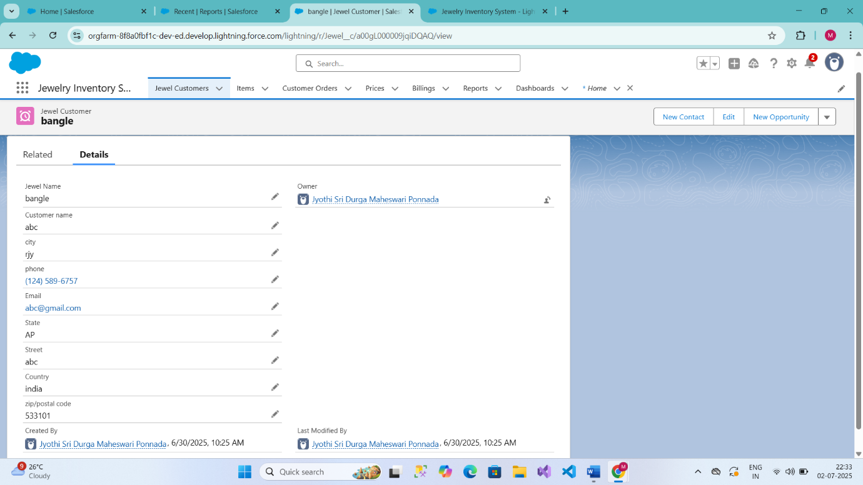

**Reports:**

Reports give you access to your Salesforce data. You can examine your Salesforce data in almost infinite combinations, display it in easy-to-understand formats, and share the resulting insights with others. Before building, reading, and sharing reports, review these reporting basics.

Types of Reports in Salesforce

1. Tabular
2. Summary
3. Matrix
4. Joined Reports

Use Case:  
The Goldsmith of an organisation wants to have a brief data on Gold Items, Silver Items, Customer Orders and Billings. So, he can have a clear picture of his organisation and be able to make any decisions required based on this data. So, he calls you on this task and wants you to represent the data in an appropriate way.

Let’s create a Report.

**Create Report**

1. Go to the app >> click on the reports tab.
2. Click New Report.
3. Select report type from category or from report type panel or from search panel >> click on start report.
4. Customise your report
5. Add fields from the left pane as shown below.
6. Save or run it.

Note: Reports may get varied from the above pictures as the data might be different.

**Reports**

1. Create a report with report type: “Item with Billings”.
2. Create a report with report type: “Billings with item and Customer order”.

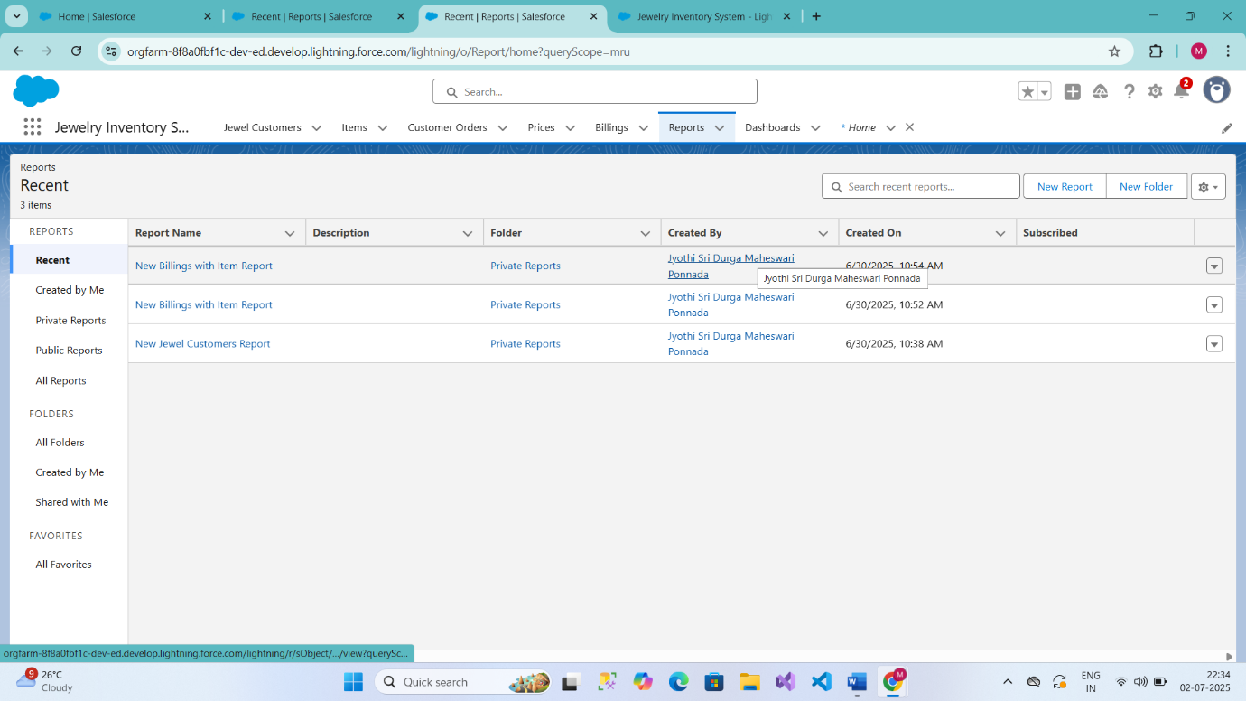

**Dashboards:**

Dashboards help you visually understand changing business conditions so you can make decisions based on the real-time data you’ve gathered with reports. Use dashboards to help users identify trends, sort out quantities, and measure the impact of their activities. Before building, reading, and sharing dashboards, review these dashboard basics.

**Use Case:**

As an Admin for the organisation, you keep pushing yourself to reach out the business requirements to take the organisation to peak heights and all your superiors are very much impressed with your efforts and work dedication. In addition, with reports you make an ease for the Goldsmith in viewing the reports with data visualisation. So, he doesn't have to search for the data he wants to check

**Create Dashboard**

1. Go to the app >> click on the Dashboards tabs.
2. Give a Name and click on Create.
3. Select add component.
4. Select a Report and click on select.
5. Click Add then click on Save and then click on Done.

Note: Create another Dashboard as we discussed in activity 1.

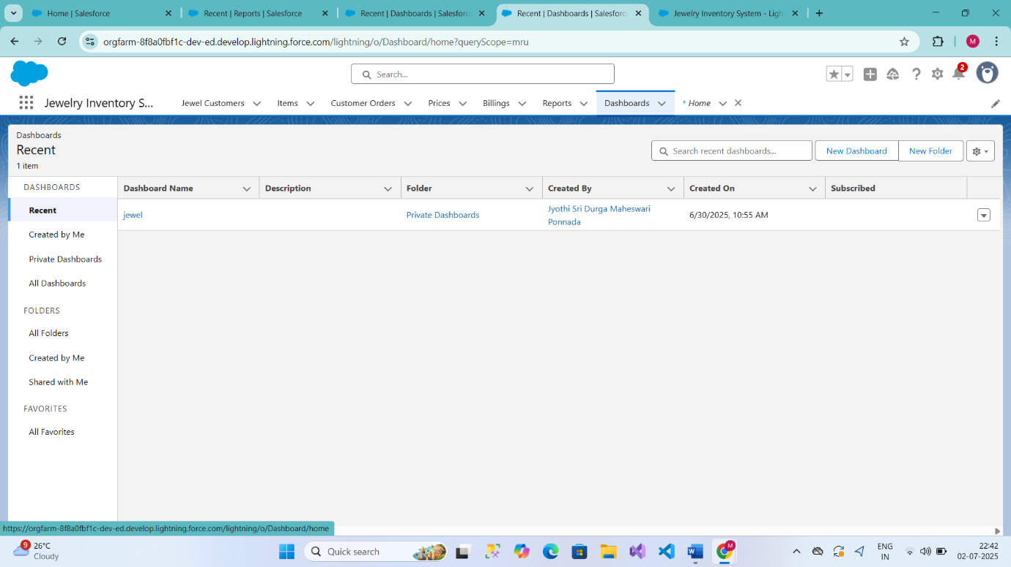

**Flows:**

In Salesforce, a flow is a powerful tool that allows you to automate business processes, collect and update data, and guide users through a series of screens or steps. Flows are built using a visual interface and can be created without any coding knowledge.

Use Case:

Flows, also known as Salesforce Flows or Visual Flows, are powerful declarative automation tools in Salesforce that allow users to create and manage complex business processes without the need for code. Flows are designed using a drag-and-drop interface, making them easy to use for both administrators and developers. They can be used for various automation tasks like email triggers including data entry, record updates, and guided user interactions.

**Create a Flow**

1. Go to setup >> type Flow in quick find box >> Click on the Flow and Select the New Flow.
2. Select the Record-triggered flow and Click on Create.
3. Select the Object as a “Billing” in the Drop-down list.
4. Select the Trigger Flow when: “A record is Created or Updated”.
5. Select the Optimise the flow for: “Actions and Related Records” and Click on Done.
6. Now change the mode form Auto-layout to free-form.
7. Now select the manger option in the toolbox, click new resource.
8. Select the resource type as text template.
9. Enter the API name as “Email body”.
10. Change the view as Rich Text >> View to Plain Text.
11. In the body field paste the syntax that is given below.

Hello

Customer Name: {! $Record. Item__r. Customer_Name__c. Name}

Here are the details for the item you purchased with Jewellery Inventory System

Item Type: {! $Record. Item__r. Item_Type__c}

Ornament: {! $Record.Ornament__c}

Weight: {! $Record.Weight__c} grams

Amount: {! $Record.Amount__c}

Click done.

1. Now click on elements, and drag the action element into the preview pane.
2. Their action bar will be opened in that search for “send email” and click on it.
3. Give the label name as “notice”
4. API name will be auto populated.
5. Enable the body in set input values for the selected action.
6. Select the text template that was created.
7. Include Recipient Address list, select the email form the record.
8. ({! $Record.Item_r. Customer_Namer.Email_c})
9. Include the subject as “Welcome to Jewellery Inventory System”.
10. Click done.
11. Now drag the path from the start to the action element.
12. Click on save. Given the Flow label, Flow Api name will be auto populated.
13. And click save, and click on active

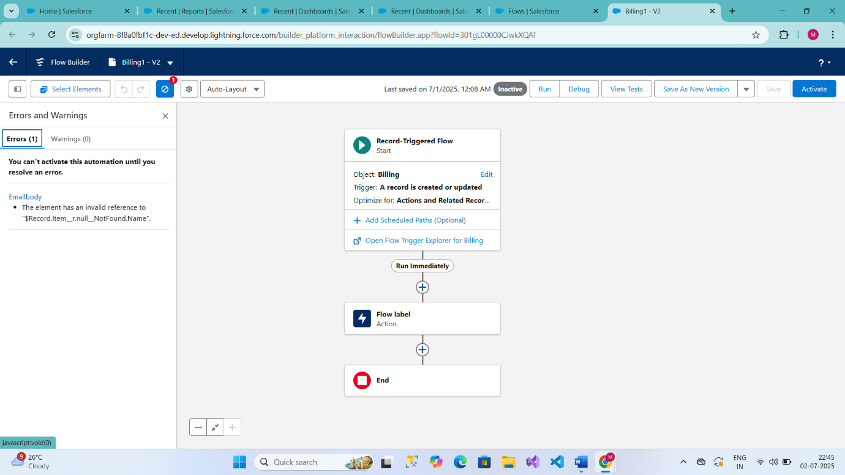*******************************END****************************